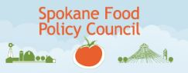

What food policy in Spokane means for you
Nathan Calene, Food Systems Planning

*Website: spokanefoodpolicy.org *Email: spokanefoodpolicy@gmail.org *April 4, 2017
SFPC Update: The Spokane Food Policy Council (SFPC) first met October 2013, and since then has been engaged in council organizational/program development, research, and outreach. Some particular areas of current and future interest include:
- farmland preservation
- K-12 nutrition
- institutional purchasing policies
- policies that allow for local food processing in or near urban areas
- incentives for grocery stores, farmers markets, and food carts to locate in underserved communities
- policies that reduce food in the waste-stream

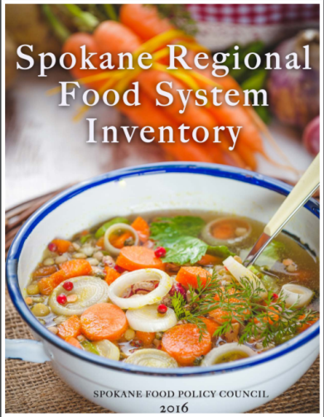
The Spokane Food Policy Council meets the third Wednesday of each month. Information on the council, as well as our past presentations and meeting summaries, can be found on the SFPC website: spokanefoodpolicy.org.
Outlined below are a few significant actions made by the SFPC in the last year.
Food System Study: In 2016, The Spokane Food Policy Council finished The Spokane Regional Food System Inventory (FSI) which is a broad assessment of the regional food system–the first of its kind for Spokane. Spokane joins other cities all across the United States that are evaluating their local food systems in an effort to improve access and quality of food for their residents and to determine their ability to provide food during economic, environmental and climatic challenges.
Addressing Food Policy in the City of Spokane’s Code: In 2014 the SFPC worked to develop an urban farming set of ordinances. In October 2016 we began an update to the urban farming ordinances: animal keeping & market gardens. Our goal is to have the update complete by the end of March or early April 2017, culminating with an Urban Agriculture Week resolution from the Spokane’s City Council.
Addressing Food Policy in Comprehensive Planning: In 2016 the SFPC worked with Spokane city planning staff to integrate food language into the City of Spokane’s Comprehensive plan. The City of Spokane’s planning department has agreed to meet with the SFPC to consider the idea of a separate food chapter within the City of Spokane’s comprehensive plan. Resources of our recommendations confirmed to be added are available at: http://spokanefoodpolicy.org/individual/
For more information or questions, please contact:
Nathan Calene at 509-279-8596, spokanefoodpolicy@gmail.org
Last Blog: https://my.spokanecity.org/news/stories/2014/11/21/what-food-policy-in-spokane-means-for-you/

